APPROVAL SHEET

MODEL NO.： SMD0805 HF Series
CUSTOMER：

CUSTOMER'S APPROVAL：

AUTHORIZED SIGNATURE/STAMP DATE

MANUFACTURER:
The Fourth Industrial Zone,Luokeng Village, Xiaotie District, Xiaojinkou Town, Huizhou City, Guangdong Province, China

Tel: 0752-7213069/7213070
Fax: 0752-7213065

Submitted by:
Approved by:
Date:

Performance Specification
Model |  |  | V_{max} |  |  | Maximum Time |  | Resistance
Model | I_{hold} | Itrip | Interrupt | I_{max} | P_{d} | To Trip
Model | (A) | (A) | (Vrms) | (A) | Typ. | Current | Time | Ri_{min.} | Ri_{max.} | R1_{max}
Model |  |  |  |  | (W) | (A) | (Sec) | (Ω) | (Ω) | (Ω)
250R020 | 0.02 | 0.04 | 250 | 1.0 | 0.6 | 0.06 | 25.0 | 60.0 | 150.0 | 200.0
250R030 | 0.03 | 0.06 | 250 | 1.0 | 0.6 | 0.09 | 20 | 35.0 | 90.0 | 120.0
250R040 | 0.04 | 0.08 | 250 | 1.0 | 0.7 | 0.20 | 0.12 | 25.0 | 65.0 | 90.0
250R050 | 0.05 | 0.10 | 250 | 1.0 | 0.7 | 0.15 | 15.0 | 22.0 | 55.0 | 75.0
250R060 | 0.06 | 0.12 | 250 | 1.2 | 0.8 | 0.18 | 15.0 | 18.0 | 45.0 | 60.0
250R080 | 0.08 | 0.16 | 250 | 1.2 | 0.8 | 0.24 | 15.0 | 11.0 | 22.0 | 33.0
250R090 | 0.09 | 0.18 | 250 | 3.0 | 1.0 | 0.35 | 5.0 | 9.0 | 18 | 27
250R110 | 0.11 | 0.22 | 250 | 3.0 | 1.0 | 1.0 | 0.75 | 6.0 | 12 | 20
250R120 | 0.12 | 0.24 | 250 | 1.2 | 1.0 | 1.0 | 0.75 | 6.0 | 12.0 | 16.0
250R145 | 0.145 | 0.29 | 250 | 3.0 | 1.0 | 1.00 | 1.50 | 4.5 | 9.0 | 14.0
250R160 | 0.16 | 0.32 | 250 | 2.0 | 1.4 | 0.48 | 25.0 | 3.5 | 7.8 | 10.4
250R180C | 0.18 | 0.65 | 250 | 10 | 1.5 | 3.0 | 0.5 | 1.6 | 3.2 | 4.0
250R180S | 0.18 | 0.65 | 250 | 10 | 1.5 | 3.0 | 0.5 | 1.6 | 3.2 | 4.0
250R200C | 0.20 | 0.40 | 250 | 3.0 | 1.5 | 0.60 | 25.0 | 3.0 | 6.5 | 8.0
250R200S | 0.20 | 0.40 | 250 | 3.0 | 1.5 | 0.60 | 25.0 | 3.0 | 6.5 | 8.0
250R250 | 0.25 | 0.50 | 250 | 3.5 | 1.5 | 0.75 | 20.0 | 2.2 | 5.0 | 6.0
250R300 | 0.30 | 0.60 | 250 | 4.5 | 1.7 | 0.90 | 20.0 | 1.8 | 4.0 | 4.8
250R330 | 0.33 | 0.66 | 250 | 4.5 | 1.7 | 0.99 | 20.0 | 1.6 | 3.6 | 4.3
250R400 | 0.40 | 0.80 | 250 | 5.5 | 2.0 | 1.20 | 25.0 | 1.35 | 3.00 | 3.6
250R500 | 0.50 | 1.0 | 250 | 6.5 | 2.5 | 1.50 | 25.0 | 0.90 | 2.00 | 2.4
250R550 | 0.55 | 1.1 | 250 | 7.0 | 2.5 | 1.65 | 25.0 | 0.80 | 1.65 | 2.0
250R600 | 0.60 | 1.2 | 250 | 6.0 | 2.5 | 1.80 | 25.0 | 0.75 | 1.50 | 1.8
250R650 | 0.65 | 1.3 | 250 | 6.5 | 2.6 | 1.95 | 30.0 | 0.65 | 1.30 | 1.6
250R750 | 0.75 | 1.5 | 250 | 7.5 | 2.6 | 2.25 | 30.0 | 0.55 | 1.10 | 1.3
250R800 | 0.80 | 1.6 | 250 | 8.0 | 2.7 | 2.40 | 30.0 | 0.50 | 1.00 | 1.2
250R900 | 0.90 | 1.8 | 250 | 9.0 | 2.8 | 2.70 | 35.0 | 0.45 | 0.90 | 1.1
250R1000C | 1.00 | 2.0 | 250 | 10.0 | 2.9 | 3.00 | 35.0 | 0.37 | 0.75 | 0.90
250R1000S | 1.00 | 2.0 | 250 | 10.0 | 2.9 | 3.00 | 35.0 | 0.37 | 0.75 | 0.90
250R1100 | 1.10 | 2.2 | 250 | 10.0 | 3.1 | 3.30 | 35.0 | 0.33 | 0.66 | 0.80
250R1250C | 1.25 | 2.5 | 250 | 10.0 | 3.3 | 3.75 | 40.0 | 0.27 | 0.55 | 0.66
250R1250S | 1.25 | 2.5 | 250 | 10.0 | 3.3 | 3.75 | 40.0 | 0.27 | 0.55 | 0.66
250R1350 | 1.35 | 2.7 | 250 | 10.0 | 3.5 | 4.05 | 40.0 | 0.25 | 0.50 | 0.60
250R1600 | 1.60 | 3.2 | 250 | 10.0 | 3.9 | 4.80 | 40.0 | 0.20 | 0.40 | 0.48
250R1850 | 1.85 | 3.7 | 250 | 10.0 | 4.3 | 5.55 | 50.0 | 0.165 | 0.33 | 0.40
250R2000 | 2.00 | 4.0 | 250 | 10.0 | 4.5 | 6.00 | 50.0 | 0.135 | 0.27 | 0.33
V max = Maximum operating voltage device can withstand without damage at rated current (Imax).
I max = Maximum fault current device can withstand without damage at rated voltage (V max).
I hold = Hold Current. Maximum current device will not trip in 25°C still air.
I trip = Trip Current. Minimum current at which the device will always trip in 25°C still air.
Pd = Power dissipation when device is in the tripped state in 25°C still air environment at rated voltage.
Ri min/max = Minimum/Maximum device resistance prior to tripping at 25°C.
R1max = Maximum device resistance is measured one hour post reflow.
CAUTION : Operation beyond the specified ratings may result in damage and possible arcing and flame.
检验项目
序号 | 检验项目 | 测试方法及条件 | 验收标准
1 | 标称电阻 | 25±2℃、静止空气 | R_{Min} ≤ R ≤ R_{Max}
2 | 不动作特性 | 25±2℃、静止空气, I_{H}保持60min | 不动作
3 | 动作时间 | 25±2℃、静止空气，初始电流3 I_{H} | T ≤ T_{Max}
4 | 耐电流电压能力 | U_{Max} / I_{Max}, 通电保持15min | 阻值变化率的极差≤30%
5 | 耐久性 | U_{Max} / I_{Max}, 通电保持24hr | 不烧不裂

Environmental Specifications
Test |  |  |  | Conditions |  |  |  | Resistance change
Passive aging |  |  |  | +85°C, 1000 hrs. |  |  |  | ±5% typical
Humidity aging |  |  |  | +85°C, 85% R.H. , 168 hours |  |  |  | ±5% typical
Thermal shock |  |  |  | +85°C to -40°C, 20 times |  |  |  | ±33% typical
Resistance to solvent |  |  |  | MIL-STD-202,Method 215 |  |  |  | No change
Vibration |  |  |  | MIL-STD-202,Method 201 |  |  |  | No change
Ambient operating conditions : - 40 °C to +85 °C
Maximum surface temperature of the device in the tripped state is 125 °C

Agency Approval and Environmental Complianc
Agency | File Number |  | Regulation | Standard
UL | pending |  |  | 2002/95/EC
TUV | pending |  |  | EN14582

Thermal Derating Curve

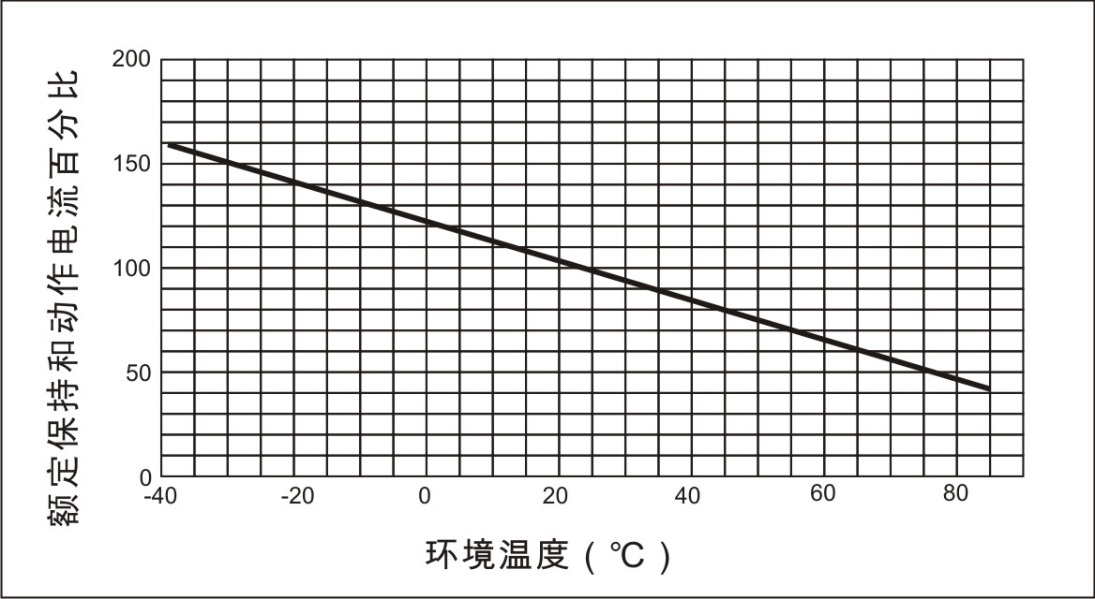
Average Time-Current Curve
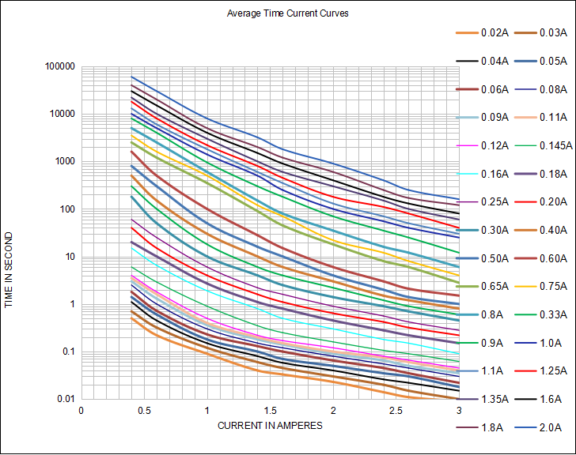

Ihold Versus Temperature
型號 | 最高環境溫度和保持電流
型號 | -40°C | -20°C | 0°C | 25°C | 40°C | 50°C | 60°C | 70°C | 85°C
250R020 | 0.030 | 0.027 | 0.024 | 0.02 | 0.017 | 0.015 | 0.013 | 0.011 | 0.008
250R030 | 0.047 | 0.04 | 0.036 | 0.03 | 0.024 | 0.022 | 0.019 | 0.016 | 0.012
250R040 | 0.062 | 0.055 | 0.048 | 0.04 | 0.033 | 0.029 | 0.026 | 0.022 | 0.016
250R050 | 0.079 | 0.69 | 0.060 | 0.05 | 0.041 | 0.036 | 0.032 | 0.027 | 0.020
250R060 | 0.101 | 0.089 | 0.077 | 0.06 | 0.052 | 0.047 | 0.041 | 0.035 | 0.026
250R080 | 0.124 | 0.110 | 0.095 | 0.08 | 0.066 | 0.059 | 0.051 | 0.044 | 0.033
250R090 | 0.140 | 0.124 | 0.107 | 0.09 | 0.074 | 0.066 | 0.057 | 0.050 | 0.037
250R110 | 0.171 | 0.151 | 0.131 | 0.11 | 0.091 | 0.081 | 0.071 | 0.061 | 0.046
250R120 | 0.186 | 0.164 | 0.143 | 0.12 | 0.098 | 0.088 | 0.077 | 0.066 | 0.049
250R145 | 0.225 | 0.199 | 0.172 | 0.145 | 0.119 | 0.106 | 0.093 | 0.080 | 0.060
250R160 | 0.248 | 0.219 | 0.190 | 0.16 | 0.131 | 0.117 | 0.102 | 0.088 | 0.064
250R180C | 0.279 | 0.247 | 0.213 | 0.18 | 0.147 | 0.131 | 0.115 | 0.099 | 0.074
250R180S | 0.279 | 0.247 | 0.213 | 0.18 | 0.147 | 0.131 | 0.115 | 0.099 | 0.074
250R200C | 0.310 | 0.274 | 0.238 | 0.20 | 0.164 | 0.146 | 0.128 | 0.110 | 0.082
250R200S | 0.310 | 0.274 | 0.238 | 0.20 | 0.164 | 0.146 | 0.128 | 0.110 | 0.082
250R250 | 0.39 | 0.34 | 0.30 | 0.25 | 0.21 | 0.18 | 0.16 | 0.14 | 0.10
250R300 | 0.47 | 0.41 | 0.36 | 0.30 | 0.25 | 0.22 | 0.19 | 0.17 | 0.12
250R330 | 0.51 | 0.45 | 0.39 | 0.33 | 0.27 | 0.24 | 0.21 | 0.18 | 0.14
250R400 | 0.62 | 0.55 | 0.48 | 0.40 | 0.33 | 0.29 | 0.26 | 0.22 | 0.16
250R500 | 0.78 | 0.69 | 0.60 | 0.50 | 0.41 | 0.37 | 0.32 | 0.28 | 0.21
250R550 | 0.85 | 0.75 | 0.66 | 0.55 | 0.45 | 0.40 | 0.35 | 0.30 | 0.23
250R600 | 0.93 | 0.82 | 0.71 | 0.60 | 0.49 | 0.44 | 0.38 | 0.33 | 0.25
250R650 | 1.01 | 0.89 | 0.77 | 0.65 | 0.53 | 0.47 | 0.42 | 0.36 | 0.27
250R750 | 1.16 | 1.03 | 0.89 | 0.75 | 0.62 | 0.55 | 0.48 | 0.41 | 0.31
250R800 | 1.24 | 1.10 | 0.95 | 0.80 | 0.66 | 0.58 | 0.51 | 0.44 | 0.33
250R900 | 1.40 | 1.23 | 1.07 | 0.90 | 0.74 | 0.66 | 0.58 | 0.50 | 0.37
250R1000C | 1.55 | 1.37 | 1.19 | 1.00 | 0.82 | 0.73 | 0.64 | 0.55 | 0.41
250R1000S | 1.55 | 1.37 | 1.19 | 1.00 | 0.82 | 0.73 | 0.64 | 0.55 | 0.41
250R1100 | 1.71 | 1.51 | 1.31 | 1.10 | 0.90 | 0.80 | 0.70 | 0.61 | 0.45
250R1250C | 1.94 | 1.71 | 1.49 | 1.25 | 1.03 | 0.91 | 0.80 | 0.69 | 0.51
250R1250S | 1.94 | 1.71 | 1.49 | 1.25 | 1.03 | 0.91 | 0.80 | 0.69 | 0.51
250R1350 | 2.09 | 1.85 | 1.61 | 1.35 | 1.11 | 0.99 | 0.86 | 0.74 | 0.55
250R1600 | 2.48 | 2.19 | 1.90 | 1.60 | 1.31 | 1.17 | 1.02 | 0.88 | 0.66
250R1850 | 2.87 | 2.53 | 2.20 | 1.85 | 1.52 | 1.35 | 1.18 | 1.02 | 0.76
250R2000 | 3.10 | 2.74 | 2.38 | 2.00 | 1.64 | 1.46 | 1.28 | 1.10 | 0.82

Soldering Parameters
Time
TP 260

100

25
Soldering
5Sea.MAX
Temperature(°C)
Gradual
Cooling

Pre-Heating
1 Minute Min.

WAVE SOLDERING INFORMATIONS
Pre-Heating Zone | Max. ramping rate should not exceed 4℃/Sec.
Soldering Zone | Max. solder temperature should not exceed 260℃
Cooling Zone | Cooling by natural convection in air.
◎Specifications are subject to change without notice.

Physical Dimensions(mm.)
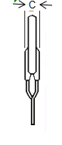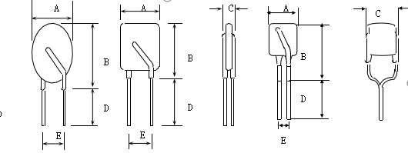

A

E

B

D

A

B

1型 2型 3型 4型

R= Trademark
R250
120
XXXY

250 = Radial type 250 V
120 = 0.12A hold current
XXX=日期

Y=代碼

Model | A | B | C | D | E | Lead
Model | Max. | Max. | Max. | Min. | Typ. | Style | 直径（Φ）
250R020 | 6.8 | 9.5 | 4.6 | 7.6 | 5.1 | 1 | 0.5
250R030 | 6.0 | 9.9 | 4.6 | 7.6 | 5.1 | 1 | 0.5
250R040 | 6.0 | 9.5 | 4.6 | 7.6 | 5.1 | 1 | 0.5
250R050 | 6.8 | 9.5 | 4.6 | 7.6 | 5.1 | 1 | 0.5
250R060 | 6.0 | 9.9 | 4.6 | 7.6 | 5.1 | 2 | 0.6
250R080 | 7.6 | 10.1 | 4.6 | 7.6 | 5.1 | 1 | 0.6
250R090 | 7.0 | 10.0 | 4.6 | 7.6 | 5.1 | 1 | 0.6
250R110 | 7.8 | 12.0 | 4.6 | 7.6 | 5.1 | 4 | 0.6
250R120 | 7.8 | 12.0 | 4.6 | 7.6 | 5.1 | 4 | 0.6
250R145 | 9.0 | 14.0 | 4.6 | 7.6 | 5.1 | 4 | 0.6
250R160 | 9.3 | 12.8 | 4.6 | 7.6 | 5.1 | 1 | 0.6
250R180C | 9.5 | 13.5 | 4.6 | 7.6 | 5.1 | 1 | 0.6
250R180S | 8.8 | 12.8 | 4.6 | 7.6 | 5.1 | 4 | 0.6
250R200C | 10.0 | 13.5 | 4.6 | 7.6 | 5.1 | 1 | 0.6
250R200S | 9.3 | 12.8 | 4.6 | 7.6 | 5.1 | 4 | 0.6
250R250 | 9.3 | 12.8 | 4.6 | 7.6 | 5.1 | 4 | 0.6
250R300 | 9.3 | 14.5 | 4.6 | 7.6 | 5.1 | 4 | 0.6
250R330 | 9.3 | 14.5 | 4.6 | 7.6 | 5.1 | 4 | 0.6
250R400 | 10.5 | 16.5 | 4.6 | 7.6 | 5.1 | 3 | 0.8
250R500 | 11.8 | 17.5 | 4.6 | 7.6 | 5.1 | 3 | 0.8
250R550 | 11.8 | 17.5 | 4.6 | 7.6 | 5.1 | 3 | 0.8
250R600 | 11.8 | 17.5 | 4.6 | 7.6 | 5.1 | 3 | 0.8
250R650 | 14.0 | 18.3 | 4.6 | 7.6 | 5.1 | 3 | 0.8
250R750 | 14.5 | 21.7 | 4.6 | 7.6 | 5.1 | 3 | 0.8
250R800 | 14.5 | 21.7 | 4.6 | 7.6 | 5.1 | 3 | 0.8
250R900 | 16.5 | 24.5 | 4.6 | 7.6 | 10.2 | 3 | 0.8
250R1000C | 21.1 | 25.1 | 4.6 | 7.6 | 10.2 | 2 | 0.8
250R1000S | 19.0 | 25.5 | 4.6 | 7.6 | 10.2 | 3 | 0.8
250R1100 | 19.0 | 25.5 | 4.6 | 7.6 | 10.2 | 3 | 0.8
250R1250C | 24.2 | 28.2 | 4.6 | 7.6 | 10.2 | 2 | 0.8
250R1250S | 19.0 | 29.0 | 4.6 | 7.6 | 10.2 | 3 | 0.8
250R1350 | 19.0 | 29.0 | 4.6 | 7.6 | 10.2 | 3 | 0.8
250R1600 | 21.5 | 29.0 | 4.6 | 7.6 | 10.2 | 3 | 0.8
250R1850 | 25.0 | 29.0 | 4.6 | 7.6 | 10.2 | 3 | 0.8
250R2000 | 25.0 | 33.5 | 4.6 | 7.6 | 10.2 | 3 | 0.8

PHYSICAL SPECIFICATIONS :
Materials :
250R020-250R050: Tin-plated copper-clad steel, 22AWG, Φ0.50mm(0.026 in).
250R060-250R330: Tin-plated copper, 22AWG, Φ0.60mm(0.026 in).
250R400-250R2000: Tin-plated copper, 22AWG, Φ0.80mm(0.026 in).
Lead Solderability : MIL-STD-202, Method 208E

Packaging Quantity
250 | 1200 | U | Model | Reel Q'ty | Bag Q'ty
Radial type | Hold | U= Bulk | 250R030~250R2000 | - | 500
250V | Current(A) | packaged | 250R030~250R2000 | - | 500

Tape & Reel packaging per EIA468-B standard.
储藏条件

温度≤40℃，湿度≤70%RH。产品在使用前最好保持在密封的原包装塑料袋中。如果贮藏在过高温度或过潮下，产品的一些性能可能会改变，比如元件引线的可焊性等。

注意事项

- 本产品不得用于故障状态下会超过最大工作电压和最大故障电流的应用类型，本产品在最大额定值以外运行和使用不当时，会导致产品损坏并有可能产生电弧和燃烧现象。
- PPTC元件并不是熔断器，而是一种能够限制电流的非线性热敏电阻。在故障状态下，所有PPTC元件均会进入到高阻状态，但并非开路状态， PPTC元件两端存在危险性的高压。
- 本产品的用途在于为电路中偶尔发生的过电流和过热故障状况提供保护，不得用于预期会频繁发生的故障状况或长时间的动作事件的场合。
- 在绝大多数应用中，PPTC元件只有在电源断开或故障状况排除后方可复位。
5. PPTC元件不建议安装在空间受限并导致PPTC特性遭到抑制的应用类型中，例如：安装在坚硬的绝缘材料内、表面添加涂层、捆绑本体等，因为此类情况缺乏能够容纳PPTC 元件膨胀的足够空间。如有要求，请对我司提出。
6. PPTC元件受到某些特定类型硅酮基油类或某些腐蚀性溶剂的污染时，元件的性能会产生不利的影响。
例如：有机溶剂清洗，清洗前最好进行试验或向我司咨询。

